GUI
15-3-26
Aim – Develop a Python GUI application to create Student Form.
Theory –
This Python program creates a graphical user interface (GUI) student form using the Tkinter library. It collects user inputs such as name, age, gender, selected subjects, and grade. Various widgets like labels, entry fields, radio buttons, checkboxes, and a combobox are used to design the interface. The submit function retrieves the entered data and displays it in a text box within the same window. Boolean variables handle multiple subject selections, while StringVar manages gender input. The place() geometry manager is used for positioning elements. This program demonstrates event-driven programming, user input handling, and basic GUI design in Python.
A1.
import tkinter as tk
from tkinter import ttk

def submit_form():
name = name_entry.get()
age = age_entry.get()
gender = gender_var.get()
subjects = []
if math_var.get():
subjects.append("Math")
if sci_var.get():
subjects.append("Sci")
if eng_var.get():
subjects.append("Eng")
grade = grade_combobox.get()

textbox.insert(tk.END, f"Name:{name}\n")
textbox.insert(tk.END, f"Age:{age}\n")
textbox.insert(tk.END, f"Gender:{gender}\n")
textbox.insert(tk.END, f"Subjects:{','.join(subjects)}\n")
textbox.insert(tk.END, f"Grade:{grade}\n")
textbox.insert(tk.END, f"~"*40+"\n")

root = tk.Tk()
root.title("Student form")
root.geometry("400x500")
tk.Label(root,text="Name:").place(x=20,y=20)
name_entry = tk.Entry(root, width =30)
name_entry.place(x=120,y=20)

tk.Label(root, text = "Age:").place(x=20,y=60)
age_entry = tk.Entry(root, width =30)
age_entry.place(x=120,y=60)

tk.Label(root, text = "Gender:").place(x=20, y =100)
gender_var = tk.StringVar(value = "None")
tk.Radiobutton(root, text = "Male", variable = gender_var, value ="Male").place(x=120,y=100)
tk.Radiobutton(root, text = "Female", variable = gender_var, value ="Female").place(x=180,y=100)

tk.Label(root,text="Subjects:").place(x=20,y=140)
math_var=tk.BooleanVar()
sci_var=tk.BooleanVar()
eng_var=tk.BooleanVar()
tk.Checkbutton(root,text="Math", variable = math_var).place(x=120,y=140)
tk.Checkbutton(root,text="Eng",variable = eng_var).place(x=120,y=170)
tk.Checkbutton(root,text="Sci",variable = sci_var).place(x=120,y=200)

tk.Label(root, text="Grade:").place(x=20,y=240)
grade_combobox = ttk.Combobox(root, values = ["A","B","C","D","E"],state = "readonly")
grade_combobox.place(x=150,y=240)

submit_button = tk.Button(root, text = "Submit", command = submit_form)
submit_button.place(x=150, y=280)

textbox = tk.Text(root, width = 40, height = 10)
textbox.place(x=20,y=320)

root.mainloop()
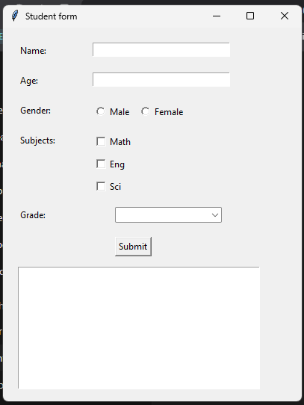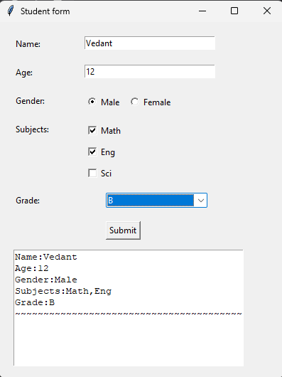
Conclusion
This application shows how Tkinter can be used to create interactive forms. It highlights input collection, widget usage, and data display. Such simple GUI programs are useful for beginners to understand user interaction and desktop application development basics.

